**PROJECT TEAM NO :-03**

**PROJECT TITLE :-**

**HOSPITAL MANGEMENT SYSTEM**



**PROJECT TEAM MEMBERS:**

**1.Saurabh Nare (Team Lead)**

**EMP ID:-2483299,**

**EMAIL-ID:-saurbh.nore@mphasis.com**

**2.SONAL AMBHORE**

**EMP ID:-2481930,**

**EMAIL-ID:-sonal.ambhore@mphasis.com**

**3.PANKAJ PALVE**

**EMP ID:-2478359,**

**EMAIL-ID:-pankaj.palve@mphasis.com**

**4.SHITAL DAHIPHALE**

**EMP ID:-2478364,**

**EMAIL-ID:-shital.dahiphale@mphasis.com**

**5.NISARGA G K**

**EMP ID:-2479538,**

**EMAIL-ID:-nisarga.k@mphasis.com**

**6.PARISA VENKATA SIVA SAI GOPI**

**EMP ID:-2481958,**

**EMAIL-ID:-parisa.saigopi@mphasis.com**

**7.KUNAPAREDDY MEGHANA**

**EMP ID:-2481805,**

**EMAIL-ID:-kunapareddy.meghana@mphasis.com**

**8.PRADIP X**

**EMP ID:-2480253,**

**EMAIL-ID:-pradip.x@mphasis.com**

**9.VEMANNA S**

**EMP ID:-2482024,**

**EMAIL-ID:-vemanna.suresh@mphasis.com**

**10.PRAJAKTA KALE**

**EMP ID:-2480257,**

**EMAIL-ID:-kale.prajakta@mphasis.com**

**TABLE OF CONTENTS:-**

1.INTRODUCTION**……………………………………**

2.SYSTEM OVERVIEW**………………………….........**

**3.** SUB-SYSTEM DETAILS**……………………………**

4.DATA ORGANIZATION**…………………………**

**5.**REST APIS TO BE BUILT**…………………………..**

**6.**ASSUMPTIONS**………………………………………**

**7.**ADVANTAGES**………………………………………**

**8.**OUTPUT SCREENSHOTS OF HMS**…………………**

# INTRODUCTION

#### ABSTRACT

**Hospital Management System** Technology has improved immensely in recent days. Improving the quality of one’s life is an important benefit of technology in healthcare. Besides, it also reduces the burden of staff in the hospital and improves the health of the patient easily and efficiently.  Hospital Management system includes registration of patients, storing their details into the system.The software has the facility to give a unique id for every patient Admin can search details of a patient using the id. The Hospital Management System can be entered using a username and password. It is accessible by an admin Only they can add data into the database. The data can be retrieved easily. The interface is very user-friendly.

## INTRODUCTION:

The project Hospital Management system includes registration of patients, storing their details into the system, and also computerized billing in the pharmacy, and labs. The software has the facility to give a unique id for every patient and stores the details of every patient and the staff automatically. It includes a search facility to know the current status of each room. User can search availability of a doctor and the details of a patient using the id.

The Hospital Management System can be entered using a username and password. It is accessible either by an administrator or receptionist. Only they can add data into the database. The data can be retrieved easily. The interface is very user-friendly. The data are well protected for personal use and makes the data processing very fast.

The purpose of the project entitled as “HOSPITAL MANAGEMENT SYSTEM” is to computerize the Front Office Management of Hospital to develop software which is user friendly, simple, fast, and cost – effective.

It deals with the collection of patient’s information, diagnosis details, etc.

The Hospital Management System simplifies the work of healthcare professionals and their interactions with their patients. Moreover, all the activities in the hospital can be recorded systematically in the digital form which helps professionals to keep track of their work.

#### 1.2 Overview

#### Objective

* + 1. Define hospital Management System
    2. Recording information about the Patients that come.
    3. Recording information related to Doctors.
    4. Recording information related to Admin.
    5. Keeping record of Status of the patients.

#### Scope of the Project:-

1. Information about Patients is done by just writing the Patients name, age and gender. Whenever the Patient comes up his information is stored freshly.
2. Diagnosis information to patients is generally recorded on the document, which contains Patient information
3. Information about various diseases is not kept as any document. Doctors themselves do this job by remembering various medicines.

All this work is done manually by the admin and other operational staff

### **MODULES:**

The entire project mainly consists of 3 modules, which are

* Admin Module
* Patient Module
* Doctor Module

**1.3.1 Admin module:**

* Admin can be signup then login No Approval Required.
* watch appointment of doctors and can be approve the requested by patient.
* Admin can be able to see the feedback which was given by the Patients.
* Admin can able to make changes in Doctors list.
* Admin can be able to make changes in patient list.

### **Patient Module:**

* Patient Can view assigned doctor's details like specialization, mobile, address
* Patient Can view their booked appointment status pending/confirmed by admin
* Patient Can view their booked appointment status pending/confirmed by admin
* Patient should fill the form when the Patient was discharged

### **Doctormodule:**

* Manage appointment withpatient
* Doctor can delete their Appoinments
* Doctor can able to see the discharged Patients list
* Doctor can be sign up

1. **. SYSTEM OVERVIEW**

#### List of Modules for Hospital Management System:

* + - **Patient Management:** Patients can sync their data from various connected health devices into their patient health record, allowing them to collaborate better in their health. Hospitals can now enhance the services for the betterment of the patients with the **Patient Management Software**.
    - **Doctor Management:** Our project in HMS Doctor Module includes registration of patients, storing their details into the system, and also computerized billing in the pharmacy, and labs. Our project has the facility to provide a unique id for each and every patient and stores the details and information of each and every patient automatically. It contains a search facility to know the current status of each patient room. User can search availability of a doctor and the details of a patient using the id.
    - **Appointment Management:**Patient can schedule their arrival close to their appointment time, which can considerably reduce their waiting time and therefore help to prevent crowding in your waiting room or store.An appointment scheduling solution, also known as appointment management software, is a solution that makes it easy for service providers to manage appointments. Appointment scheduling solutions have a lot of advantages, both service providers and their customers.

These Admin,Doctor,Patient modules must be present in creating the Hospital Management to satisfy the needs in managing Hospital transactions. It increases the competency of your hospital legitimately and also helps to improve your hospital quality.

#### REQUIREMENTSPECIFICATION

#### INTRODUCTION:

#### The Requirement Specification is the process of writing down the user and system requirements into a document. The requirements should be clear, easy to understand, complete, and consistent.The requirements specification and requirements map are the results of the analysis process.

#### HARDWAREREQUIREMENTS:

The **hardware requirements** are the requirements of a hardware device. Most hardware only has operating system requirements or compatibility. The most common set of requirements defined by any operating system or software application is the physical computer resources, also known as hardware, A hardware requirements list is often accompanied by a hardware compatibility list (HCL), especially in case of operating systems. The following sub-sections discuss the various aspects of hardware requirements.

#### HARDWARE REQUIREMENTS FOR PRESENT PROJECT:

PROCESSOR : DELL

RAM : 4 GB

HARDDISK : 1TB

#### SOFTWAREREQUIREMENTS:

1. A Software Requirements Specification (SRS) is a document that describes the nature of a project, software or application.

A Software requirements specification document describes the intended purpose, requirements and nature of a software to be developed. It also includes the yield and cost of the software. A System Requirements Specification (SRS) (also known as a Software Requirements Specification) is **a document or set of documentation that describes the features and behavior of a system or software application**.

#### SOFTWARE REQUIREMENTS FOR PRESENT PROJECT:

OPERATING SYSTEM: Windows 10

FRONTEND : Html, CSS, Angular

BACKEND : Spring Boot

SERVER SIDESCRIPT : Apache tomcat8

DATABASE : MySql Workbench

* + AUTHENTICATION AND AUTHORIZATION:

Authentication:

Every time we signed up, we likely been asked to create a username and password. Because this is such a common process now, it's become almost second-nature for some users to set up their accounts without much thought about the credentials they choose. And unfortunately, there's a lot at stake if a user chooses weak credentials.

Authentication for Username and password:

When a user first signs up for website, they're asked to choose a username and password to identify themselves. In an ideal world, the user would always pick a strong and unique password so that it's harder for an attacker to guess.

Password Rules:

When it comes to password safety, the longer and more complex the password is, the better. We think its good practice to enforce certain minimum requirements when asking users to create a new password. Of course, you have to find a balance between these requirements and user experience. If you make the sign-up process too tedious, you could be driving users away. To enforce password strength, you should define a set of rules that a password must satisfy and then enforce these with form validation.

Example password strength rules:

* + - Minimum of 8characters
    - Maximum of 16 characters
    - Conform password and Main password should be same

2.3.1 Authorization:

For Authorization, think of owning a hospital page. When admin log in, since he own the page. Hence, admin can post content on page, modify and even approve content from doctors and patient and others of your page that are not administrators. When users who are not administrators try to approve other people's content, they'll find out they can't. This is because they don't have the right to do that; only admins can.

* + **E-R DIAGRAMS**

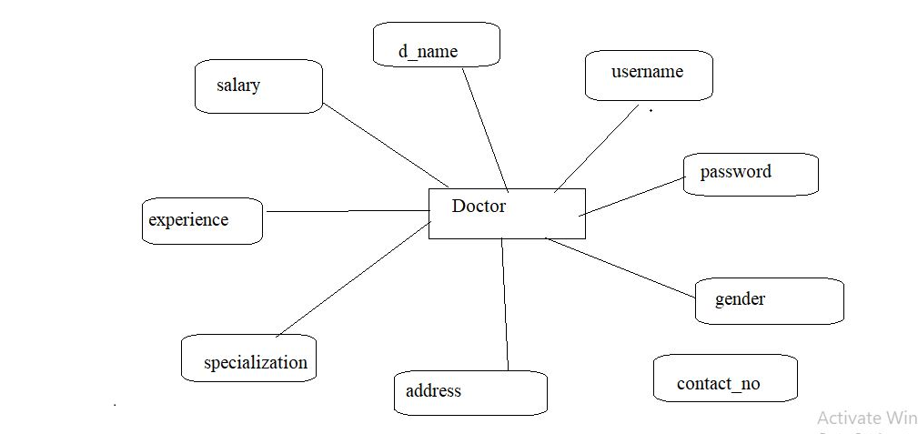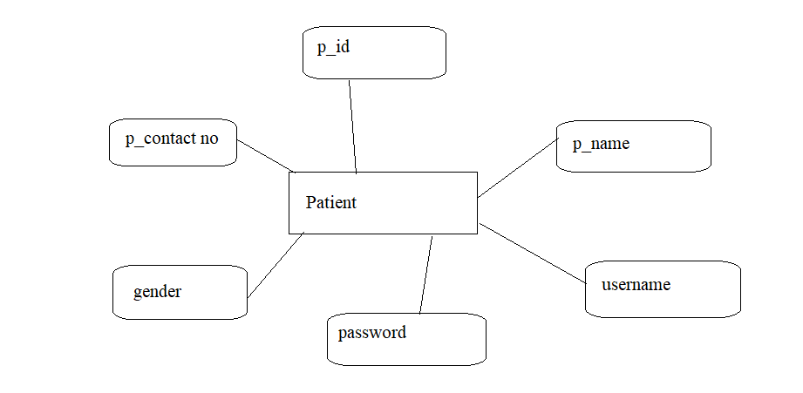

### 

Patient signuptable:

|  |  |  |  |
| --- | --- | --- | --- |
| **Column** | **Data Type** | **Length** | **Nulls** |
| **User name** | **varchar** | 255 | no |
| **Password** | **varchar** | **255** | yes |
| **P-id** | **Int** |  |  |
| **P-Contact No** | **varchar** | **255** | yes |
| **P-gendr** | **varchar** | **255** | yes |
| **P-Name** | **varchar** | **255** | yes |

Doctor signup table:

|  |  |  |  |
| --- | --- | --- | --- |
| **Column Name** | **Data Type** | **Length** | **Nulls** |
| **d_ID** | **Int** |  | **-** |
| **Accept** | **Varchar** | **255** | **Yes** |
| **Address** | **Varchar** | **255** | **Yes** |
| **Contact-no** | **Varchar** | **255** | **Yes** |
| **d-name** | **Varchar** | **255** | **Yes** |
| **Experience** | **Varchar** | **255** | Yes |
| **gender** | **Varchar** | **255** | Yes |
| **Password** | **varchar** | **255** | Yes |
| **Salary** | **varchar** | **255** | Yes |
| **Specialization** | **varchar** | **255** | Yes |

PatientLogin:

|  |  |  |  |
| --- | --- | --- | --- |
| **Column Name** | **Data Type** | **Length** | **Nulls** |
| **username** | **Varchar** | **255** | **-** |
| **password** | **Varchar** | **255** | **-** |

* DoctorLogin:

|  |  |  |  |
| --- | --- | --- | --- |
| **Column Name** | **Data Type** | **Length** | **Nulls** |
| **username** | **Varchar** | **255** | **-** |
| **password** | **Varchar** | **255** | **-** |

AdminLogin:

|  |  |  |  |
| --- | --- | --- | --- |
| **Column Name** | **Data Type** | **Length** | **Nulls** |
| **username** | **Varchar** | **255** | **-** |
| **password** | **Varchar** | **255** | **-** |

Appointment Table:

|  |  |  |  |
| --- | --- | --- | --- |
| **Column Name** | **Data Type** | **Length** | **Null** |
| **Ap-id** | **Number** |  |  |
| **Address** | **Varchar** | **255** | Yes |
| **Ap-date** | **Varchar** | **255** | Yes |
| **Ap-time** | **Varchar** | **255** | Yes |
| **D-name** | **Varchar** | **255** | Yes |
| **disease** | **Varchar** | **255** | Yes |
| **gender** | **Varchar** | **255** | Yes |
| **p-name** | **Varchar** | **255** | yes |

Feedback table:

|  |  |  |  |
| --- | --- | --- | --- |
| **Column Name** | **Data Type** | **Length** | **Nulls** |
| **Feedback_id** | **Int** |  |  |
| **P_comments** | **Varchar** | **255** | Yes |
| **P-id** | **Int** |  | Yes |

# 3. Sub-System Details

The Hospital Management System is defined, where in all users need to login successfully before performing any of their respective operations. Below tables that provides functionality descriptions for each type of user . Against each requirement, indicative data is listed in column ‘Data to include’.

* 1. Admin

###### The admin as a user is defined to perform below listed operations after once admin login.

|  |  |  |  |
| --- | --- | --- | --- |
| **Objects** | **Operations** | **Data to include** | **Remarks** |
| User | register | Admin id,admin name, contact  no,username,password |  |
| Doctor list | view | Doctor id, doctor name |  |
| Appointments | Approve/reject | Appointment id, address, date, status, time, doctor id, patient id |  |
| Patients List | view | Patient id, patient name |  |

## Doctor

###### The doctor as a user is defined to perform below listed operations after once doctor login.

|  |  |  |  |
| --- | --- | --- | --- |
| **Objects** | **Operations** | **Data to include** | **Remarks** |
| **User** | Register | Doctor id, doctor name,  username, password, gender, mail id, specialization |  |
| **Patients Lists** | View | Patient id, patient name |  |
| **Appointments** | View | Patient id, disease, appointment time |  |
| **Discharge Patients** |  | Patient id, patient name |  |

## Patient

## The Patient as a user is defined to perform below listed operations after once Patient login.

|  |  |  |  |
| --- | --- | --- | --- |
| **Objects** | **Operations** | **Data to include** | **Remarks** |
| User | Register | Patient id, dob, contactNo, gender, patient name, password |  |
| Appointment | Register | Appointment id, address, date, status, time, doctor id, patient id |  |

# 

# 4 Data Organization

###### This section explains the data storage requirements of the Product Order Entry System and indicative data description along with suggested table (database) structure. The following section explains few of the tables (fields) with description. However, in similar approach need to be considered for all other tables.

###### **Admin Registrationtable**

|  |  |
| --- | --- |
| **Field Name** | **Description** |
| Admin_id | Admin id is auto generated after registration and it is used as Login ID. |
| Admin_name | Name of the admin |
| Username | Name of the admin |
| Password | User unique password |

###### **Patient Registrationtable**

|  |  |
| --- | --- |
| **Field Name** | **Description** |
| Patient_id | Patient id is auto generated after registration and it is used as Login ID. |
| Patient_name | Name of the Patient |
| Patient_gender | Give gender weather Male\Female |
| Username | Name of the Patient |
| Password | User unique password |
| Patient contact number | 1. igits patient mobile number |

###### **4.3 Doctor Registration table**

|  |  |
| --- | --- |
| **Field Name** | **Description** |
| Doctor_id | Doctor id is auto generated after registration and it is used as Login ID. |
| Doctor_name | Name of the doctor |
| Contact_no | 10 digits mobile number |
| Username | Name of the Doctor |
| Password | User unique password |
| Gender | Mention whether doctor male\female |
| Specialization | Doctor Specialization or expert |

###### **Appointmenttable**

|  |  |
| --- | --- |
| **Field Name** | **Description** |
| Appointment_id | Appointment id is auto generated after appointment filled successfully. |
| Patient_id | Id of patient |
| Doctor_id | Id of the doctor to whom you were referred |
| Address | Complete Address of the Patient |
| Appointment time | At what time the patient want to schedule the appointment |

###### **4.5.Feedback table**

|  |  |
| --- | --- |
| **Field Name** | **Description** |
| Patient_id | Id of patient |
| Comments | Feedback to be given In 50 words |

###### **4.6.DischargeTable**

|  |  |
| --- | --- |
| **Field Name** | **Description** |
| Appointment_id | Appointment id which was given |
| Patient_id | Id of patient |
| Discharge_date | The date of discharge |
| Disease | Patient Disease |
| Amount paid | Clearance of bill amount |

# 

# 5 REST APIS TO BE BUILT.

###### Create following REST resources which are required in the application,

###### 1. Creating Admin Entity: Create Spring Boot with Microservices Application with Spring Data JPA

###### Technology stack:

###### Spring Boot

###### Spring REST

###### Spring DataJPA

###### Here will have multiple layers into the application:

###### Create an Entity:Admin

###### Create a AdminRepository interface and will make use of Spring DataJPA

###### Will have findByAdminmemethod.

###### Add the Admindetails

###### Create a Admin Service class and will expose all theseservices.

###### Finally, create a AdminRestController will have the followingUri’s:

http://localhost:8081/adminlogin

http://localhost:8081/registerAdmin

http://localhost:8081/api/v1/appointments

http://localhost:8081/api/v1/dischargedpatients<http://localhost:8081/api/v1/feedbac>

http://localhost:8081/api/v1/doctors

http://localhost:8081/api/v1/doctorlogin

http://localhost:8081/api/v1/feedbacks

http://localhost:8081/api/v1/patientlogin

http://localhost:8081/api/v1/patients

http://localhost:8081/api/v1/patient

http://localhost:8081/registerAdmin

# 

# 6.Assumptions

* Each user(Admin, doctor, patient) must have a valid user id and password
* Server must be running for the system to function
* Users must log in to the system to access any record.
* Only the Administrator can delete records.

###### Only admin can approve appointment, discharge, generate invoice.

**7.ADVANTAGES:**

* 1. Obtain the Best Quality Rating
  2. Digital Medical Records
  3. Less time consuming
  4. Revenue Management
  5. Patient self-service

6.Nullify every Error and Track complete details.

Obtain the Best Quality Ratings :

When your clinics or hospital needs to be the top-rated and top preferred ones by insurance companies, then you must implement a Hospital Management Systems in your hospital. Insurance companies and medicare companies depend on digital data only when there is an automated system in the hospital.

If your clinic is capable of sending and receiving the information of the patients, their medical records digitally, then it means your hospital is going to be the highest preference among the patients. An accurate and rapid Hospital Management System stands out the top among other nursing homes, medical centers, and other hospital competitors. It adds significant value to your hospital and also provides a reputation in the market.

Digital medical records :

The hospital database includes all the necessary patient data. The disease history, test results, prescribed treatment can be accessed by doctors without much delay in order to make an accurate diagnosis and monitor the patient’s health. It enables lower risks of mistakes.

Less time consuming:

As the services and interactions are improved in all possible ways, everything is being planned with greater precision. It saves the time of all the system users and provides them with up-to-date information.

Revenue Management

A medical center or hospital serves humanity. Apart from that, profit is more important as it also considered to be a business.  Revenue management is one of the significant elements as it needs the fortune to manage a hospital. Also, it's not possible to track the identical thing with the help of the old-age manual system. An Automated HMS which is catered as per the needs of the business can help in solving the purpose efficiently.

It provides accurate and rapid management and transactional reports, which offer a clear view of how your business is performing. What are the debts and interests, pending invoices, and outstanding amounts?

Apart from that, there is also a decrease in the operating cost because of actual operational effectiveness. When processes and systems are automated, there is no need for higher resources to manage the operations. It means the faster break-even point and improved ROI can be achieved easily.

Nullify every error and track complete details:

Managing a hospital is not much easy, and there are chances for some mistakes to occur. A manual system can ensure 100% accurate processing and foolproof. There are higher chances for mistakes and errors in this case. To eradicate this, the best decision is to install an automation hospital management system that highly nullifies every mistake and also you can avoid lawsuits and compliance issues, which is considered to be the two most significant drawbacks of hospitals and medical centers.

Apart from this, tracking the accurate details of staff availability, operational information, and room occupancy can also be readily available at your fingerprints by using the automated Hospital Information System.

# 8.OUTPUT SCREENSHOTS OF HMS

# 

# 

**CONCLUSION:**

Hospital management systems allows us the ability to optimize and digitize all the processes within the institution, which will help to improve customer service, reduce process costs, streamline the search of medical records, bills, patients, doctors, etc.; thus, having a database of each module implemented. HMS will contributed enormously to better health and influenced the lives and well-being of billions of humans.